LAPORAN PRAKTIKUM
MATA KULIAH PEMROGRAMAN WEB
Modul 8: Pengantar Framework & MVC Architecture + CodeIgniter 3



Oleh:
Davin Aileenskie Sofiandy
707012500135
D4SIKC 49-04

PROGRAM STUDI S.Ter SISTEM INFORMASI KOTA CERDAS
FAKULTAS ILMU TERAPAN
UNIVERSITAS TELKOM
BANDUNG
2026

8.1 Tujuan
Setelah menyelesaikan praktikum ini, mahasiswa diharapkan mampu:
1. Memahami konsep dan fungsi framework dalam pengembangan aplikasi web.
2. Memahami arsitektur MVC (Model-View-Controller).
3. Menjelaskan arsitektur dan konsep dasar CodeIgniter 3.
4. Menginstal dan mengonfigurasi CodeIgniter 3.
5. Membuat routing dan controller pada CI3.
6. Mengimplementasikan view dan template system.
7. Menghubungkan model dengan database.
8. Mengintegrasikan komponen MVC menjadi aplikasi utuh.
9. Mengimplementasikan form handling dan validation.
10. Mengelola session, autentikasi, dan role management.
11. Menerapkan praktik keamanan dasar pada aplikasi CI3.
8.2 Alat dan Bahan
Untuk melaksanakan praktikum ini, diperlukan:
1. Laptop/PC dengan XAMPP terinstal.
2. PHP versi minimal 7.x.
3. Database MySQL/MariaDB.
4. Code Editor (VS Code/Sublime/PHPStorm).
5. Browser (Chrome/Firefox).
6. CodeIgniter 3 (download dari https://codeigniter.com).

Hasil dan Program
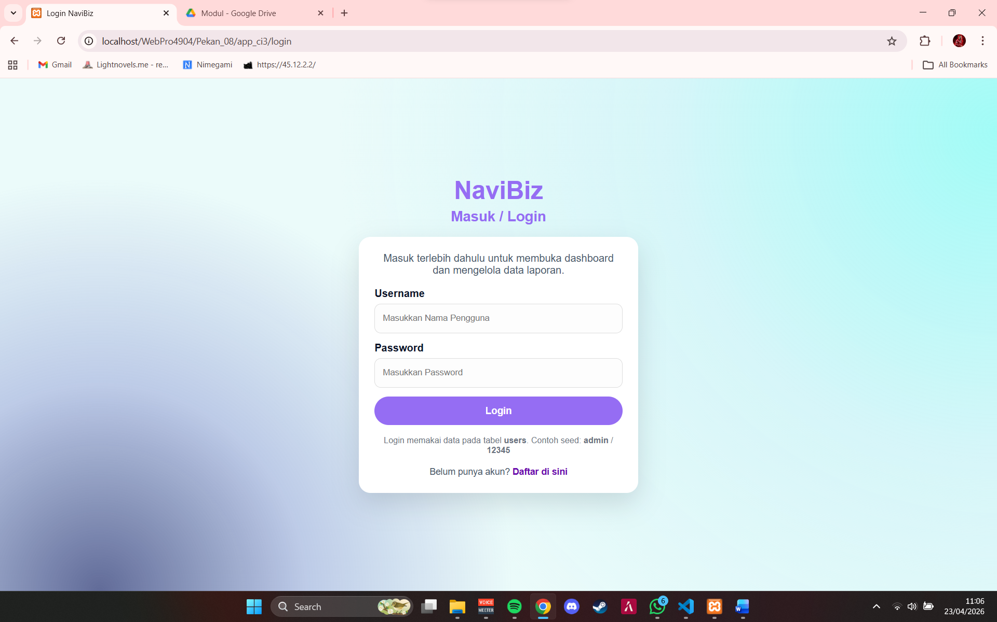

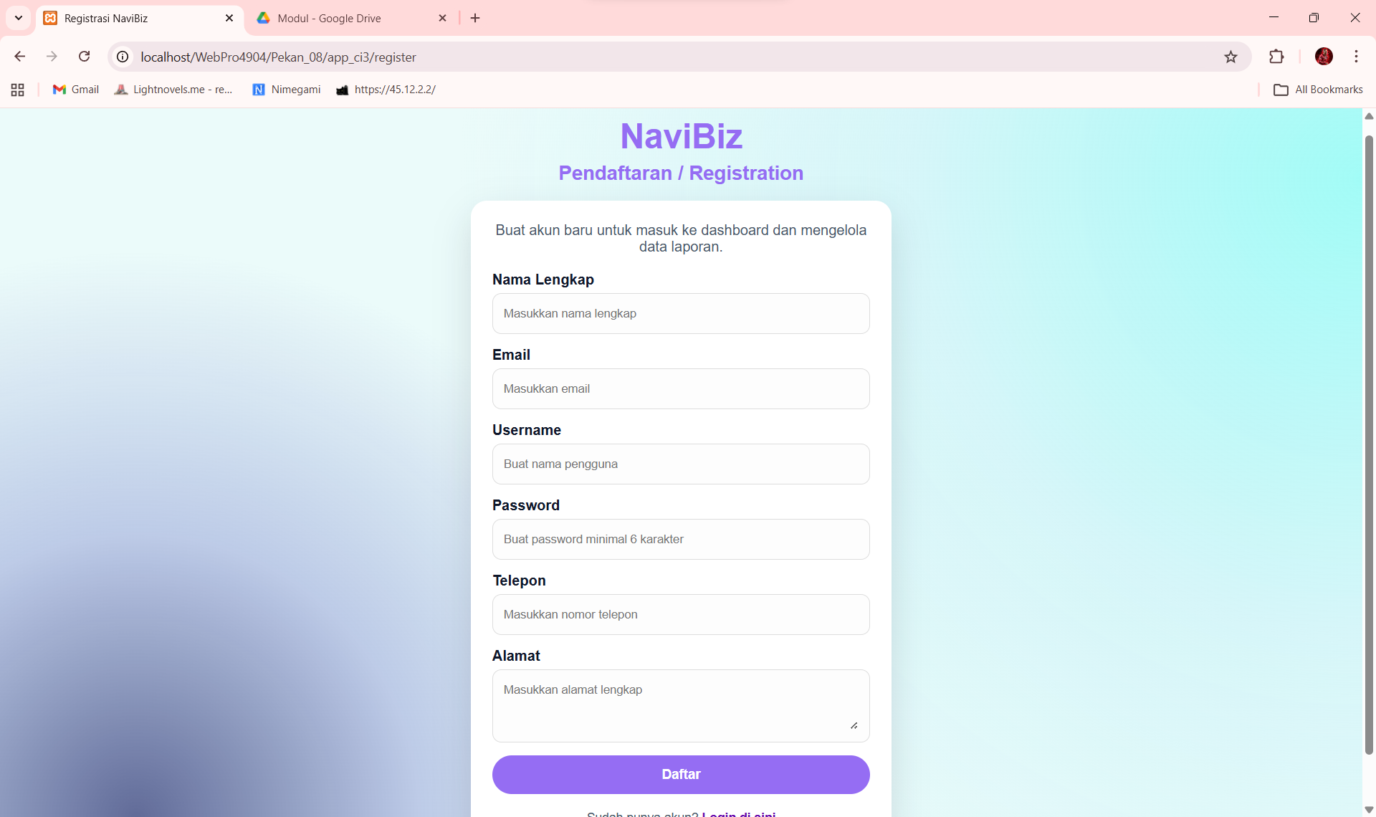

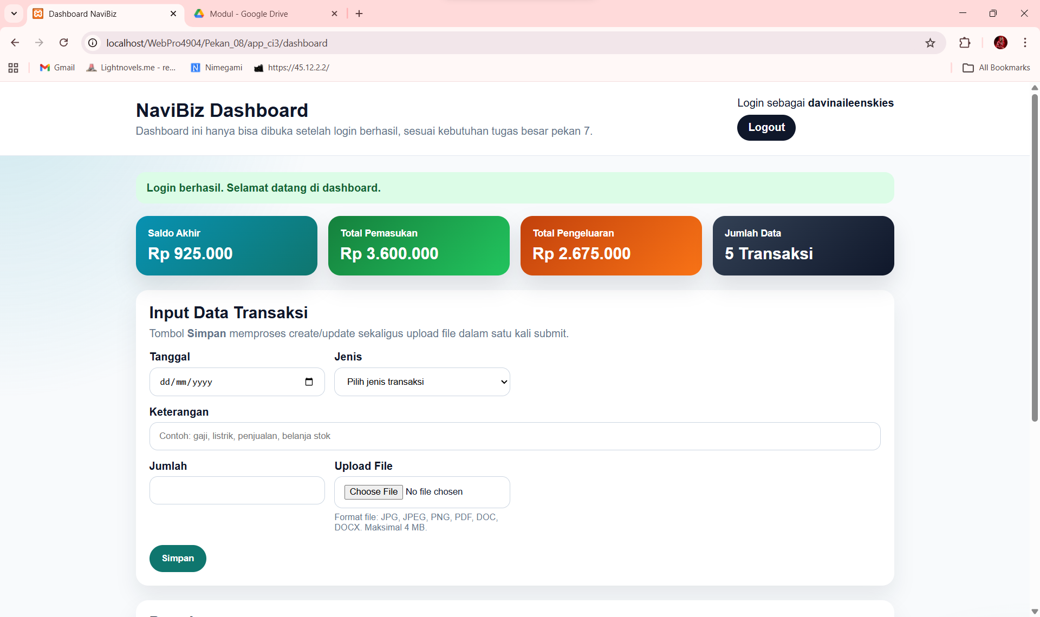
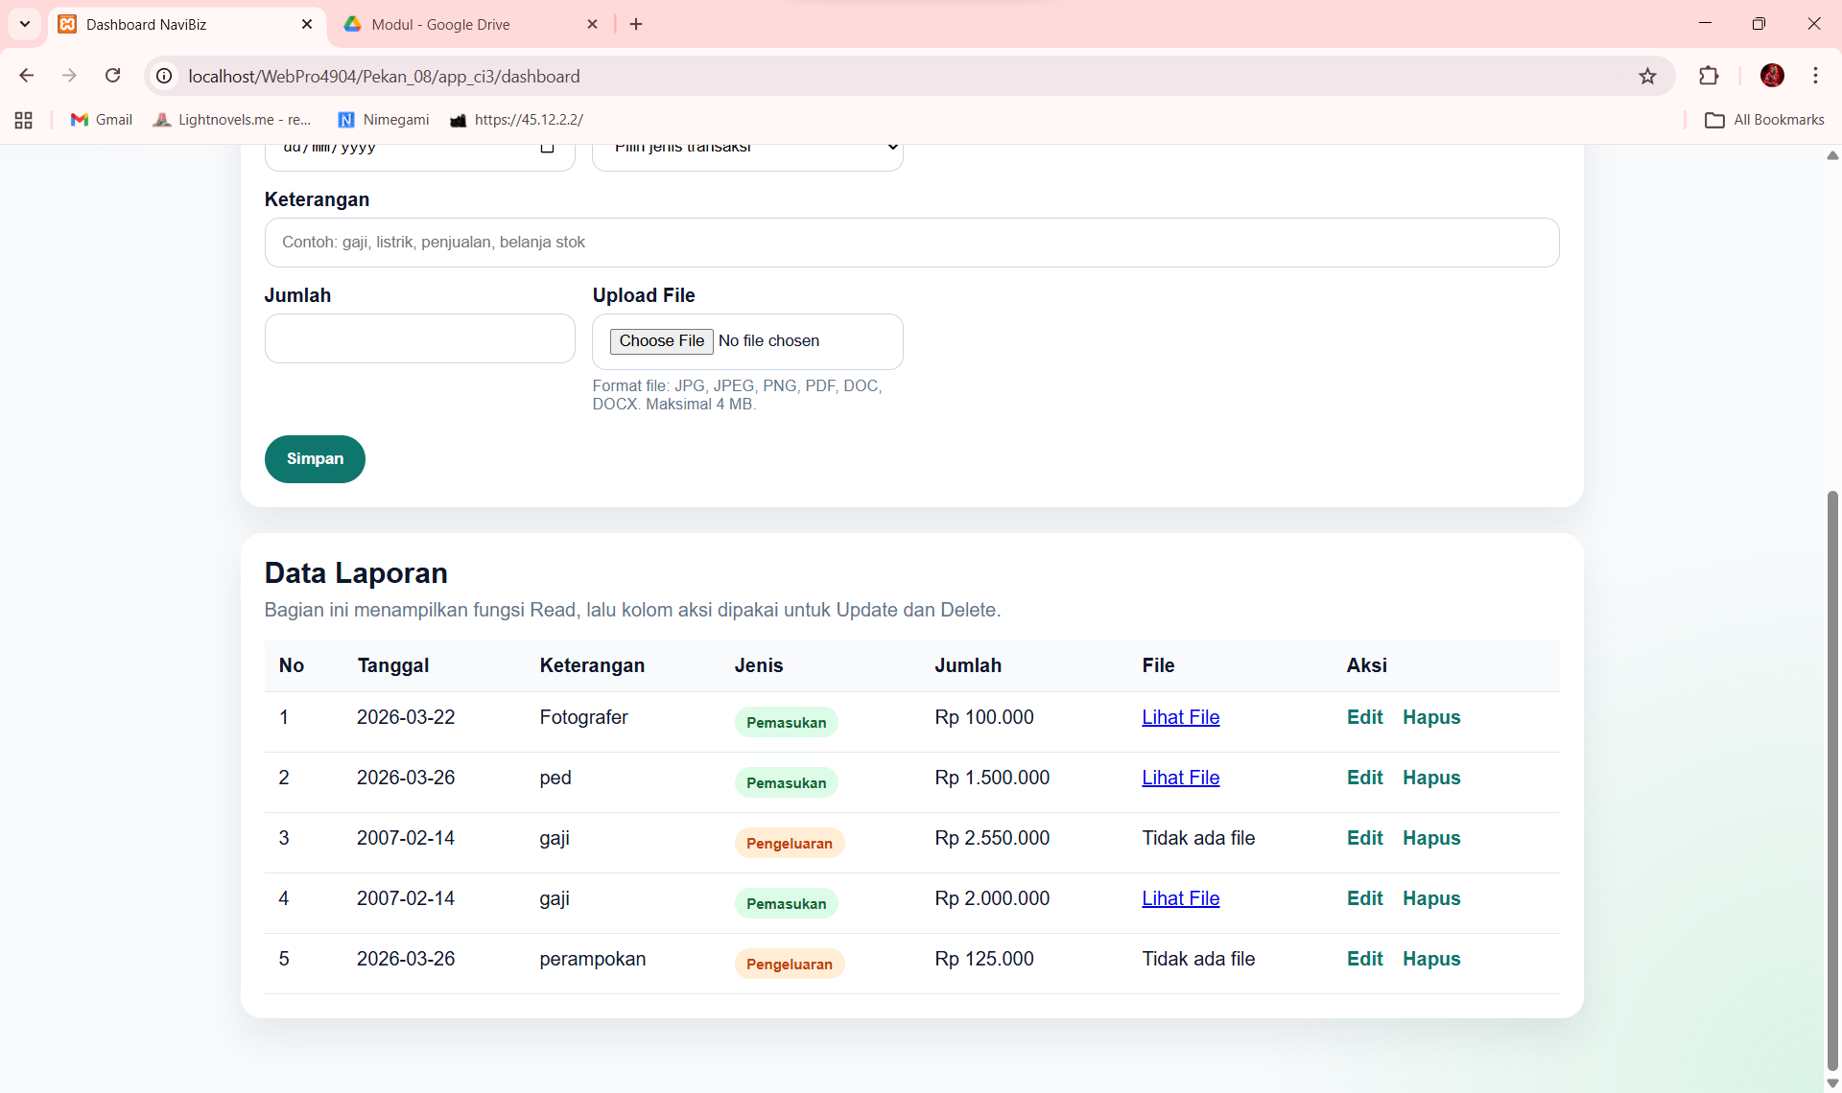
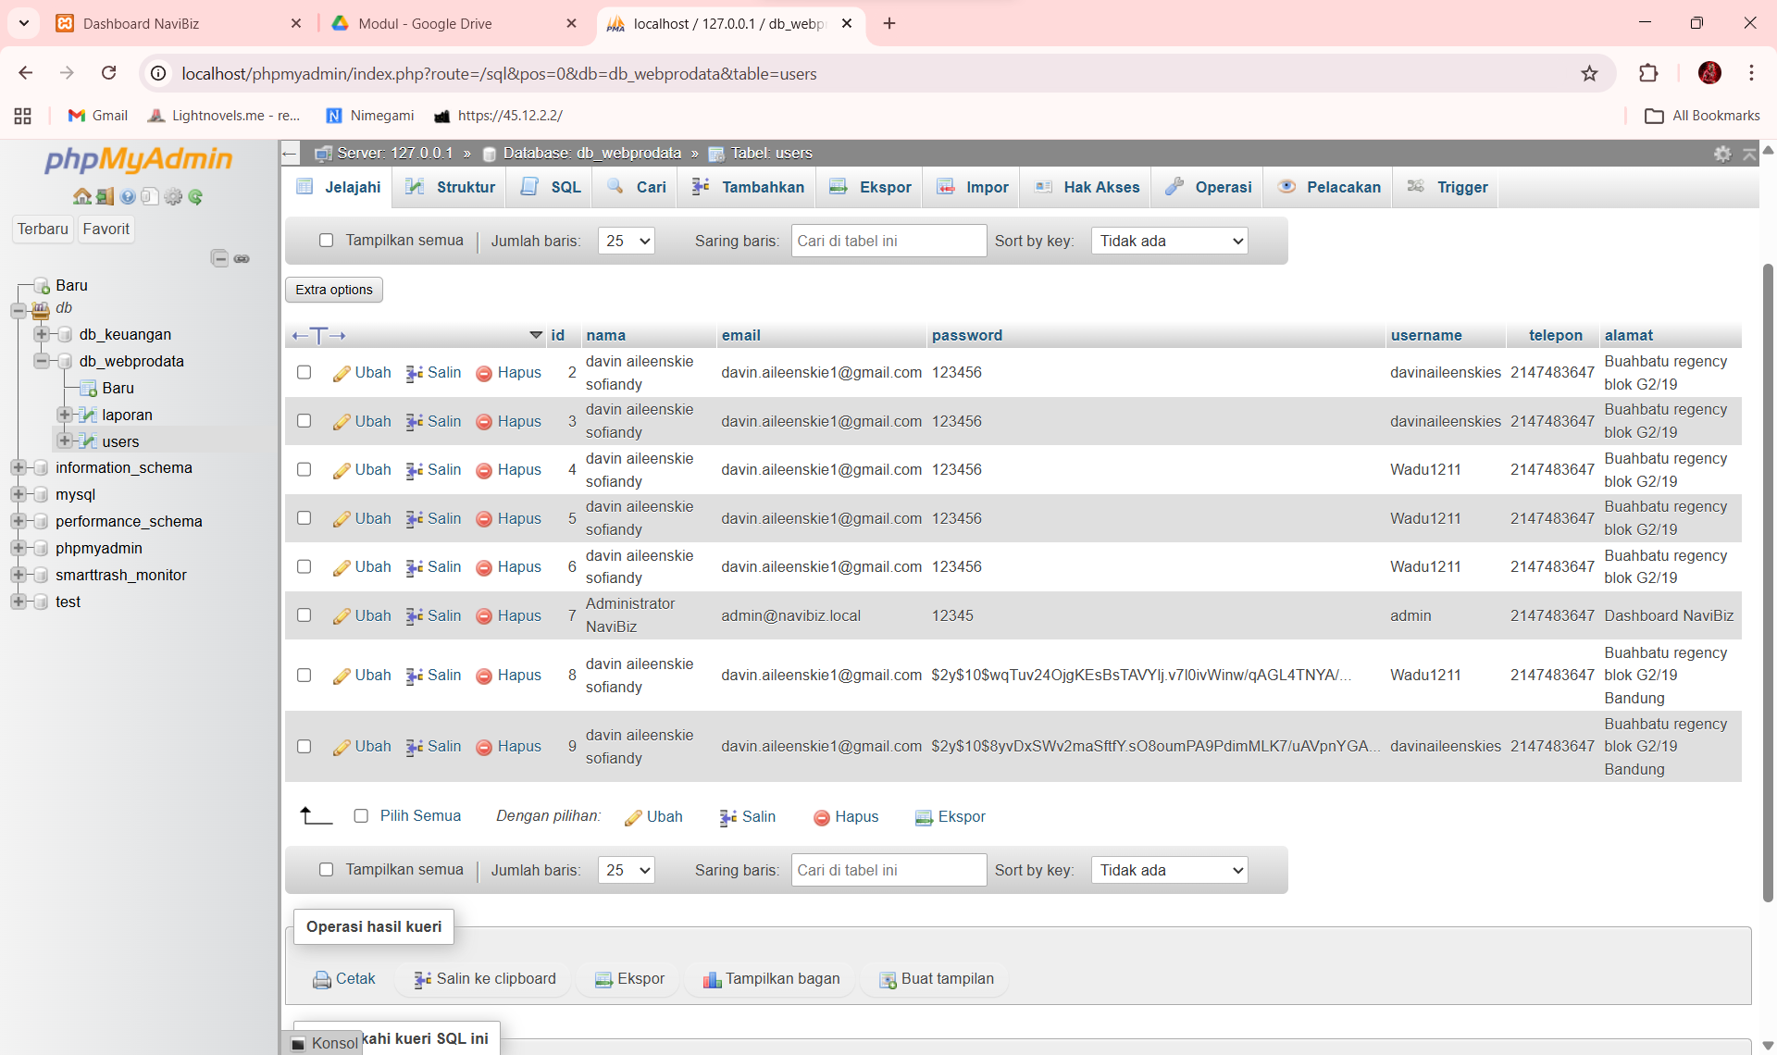
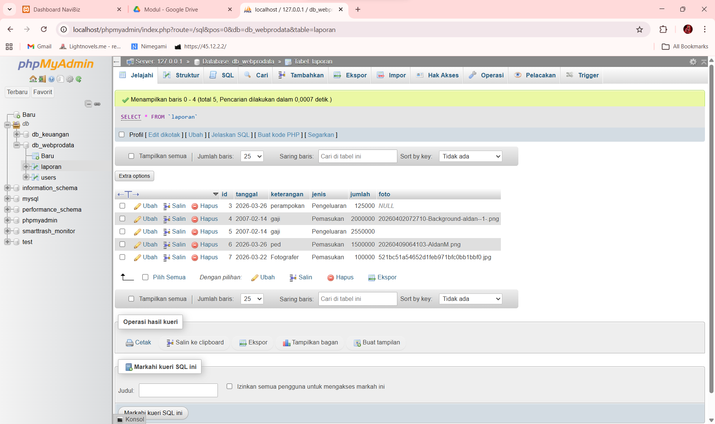
<?php
defined('BASEPATH') OR exit('No direct script access allowed');

/*
| -------------------------------------------------------------------------
| URI ROUTING
| -------------------------------------------------------------------------
| This file lets you re-map URI requests to specific controller functions.
|
| Typically there is a one-to-one relationship between a URL string
| and its corresponding controller class/method. The segments in a
| URL normally follow this pattern:
|
| example.com/class/method/id/
|
| In some instances, however, you may want to remap this relationship
| so that a different class/function is called than the one
| corresponding to the URL.
|
| Please see the user guide for complete details:
|
| http://codeigniter.com/user_guide/general/routing.html
|
| -------------------------------------------------------------------------
| RESERVED ROUTES
| -------------------------------------------------------------------------
|
| There are three reserved routes:
|
| $route['default_controller'] = 'welcome';
|
| This route indicates which controller class should be loaded if the
| URI contains no data. In the above example, the "welcome" class
| would be loaded.
|
| $route['404_override'] = 'errors/page_missing';
|
| This route will tell the Router which controller/method to use if those
| provided in the URL cannot be matched to a valid route.
|
| $route['translate_uri_dashes'] = FALSE;
|
| This is not exactly a route, but allows you to automatically route
| controller and method names that contain dashes. '-' isn't a valid
| class or method name character, so it requires translation.
| When you set this option to TRUE, it will replace ALL dashes in the
| controller and method URI segments.
|
| Examples: my-controller/index -> my_controller/index
| my-controller/my-method -> my_controller/my_method
*/
$route['default_controller'] = 'auth';
$route['404_override'] = '';
$route['translate_uri_dashes'] = FALSE;

$route['login'] = 'auth';
$route['register'] = 'auth/register';
$route['logout'] = 'auth/logout';
$route['dashboard'] = 'dashboard';
$route['dashboard/simpan'] = 'dashboard/save';
$route['dashboard/hapus/(:num)'] = 'dashboard/delete/$1';

<?php
defined('BASEPATH') OR exit('No direct script access allowed');

class Auth extends MX_Controller
{
public function __construct()
{
parent::__construct();
$this->load->model('auth/User_model', 'user_model');
}

public function index()
{
if ($this->session->userdata('logged_in')) {
redirect('dashboard');
}

if ($this->input->method() === 'post') {
$username = trim((string) $this->input->post('username', TRUE));
$password = trim((string) $this->input->post('password', TRUE));

if ($username === '' || $password === '') {
$this->session->set_flashdata('message', array(
'type' => 'error',
'text' => 'Username dan password wajib diisi.',
));
redirect('login');
}

$user = $this->user_model->verify_credentials($username, $password);

if ($user) {
$this->session->set_userdata(array(
'logged_in' => TRUE,
'user_id' => (int) $user->id,
'username' => $user->username,
));

$this->session->set_flashdata('message', array(
'type' => 'success',
'text' => 'Login berhasil. Selamat datang di dashboard.',
));
redirect('dashboard');
}

$this->session->set_flashdata('message', array(
'type' => 'error',
'text' => 'Login gagal. Username atau password pada tabel users tidak cocok.',
));
redirect('login');
}

$data['message'] = $this->session->flashdata('message');
$this->load->view('auth/login', $data);
}

public function logout()
{
$this->session->sess_destroy();
redirect('login');
}

public function register()
{
if ($this->session->userdata('logged_in')) {
redirect('dashboard');
}

if ($this->input->method() === 'post') {
$nama = trim((string) $this->input->post('nama', TRUE));
$email = trim((string) $this->input->post('email', TRUE));
$username = trim((string) $this->input->post('username', TRUE));
$password = (string) $this->input->post('password');
$telepon = trim((string) $this->input->post('telepon', TRUE));
$alamat = trim((string) $this->input->post('alamat', TRUE));

if ($nama === '' || $email === '' || $username === '' || $password === '' || $telepon === '' || $alamat === '') {
$this->session->set_flashdata('message', array(
'type' => 'error',
'text' => 'Semua field pendaftaran wajib diisi.',
));
redirect('register');
}

if (!filter_var($email, FILTER_VALIDATE_EMAIL)) {
$this->session->set_flashdata('message', array(
'type' => 'error',
'text' => 'Format email tidak valid.',
));
redirect('register');
}

if (strlen($password) < 6) {
$this->session->set_flashdata('message', array(
'type' => 'error',
'text' => 'Password minimal 6 karakter.',
));
redirect('register');
}

$this->user_model->create(array(
'nama' => $nama,
'email' => $email,
'username' => $username,
'password' => password_hash($password, PASSWORD_DEFAULT),
'telepon' => $telepon,
'alamat' => $alamat,
));

if ($this->db->affected_rows() > 0) {
$this->session->set_flashdata('message', array(
'type' => 'success',
'text' => 'Registrasi berhasil. Silakan login dengan akun yang baru dibuat.',
));
redirect('login');
}

$this->session->set_flashdata('message', array(
'type' => 'error',
'text' => 'Registrasi gagal disimpan ke database. Cek struktur tabel users.',
));
redirect('register');
}

$data['message'] = $this->session->flashdata('message');
$this->load->view('auth/register', $data);
}
}

<?php
defined('BASEPATH') OR exit('No direct script access allowed');

class User_model extends CI_Model
{
private $table = 'users';

public function find_by_username($username)
{
return $this->db->get_where($this->table, array('username' => $username))->row();
}

public function verify_credentials($username, $password)
{
$users = $this->db
->where('username', $username)
->order_by('id', 'DESC')
->get($this->table)
->result();

if (empty($users)) {
return NULL;
}

foreach ($users as $user) {
$stored_password = (string) $user->password;

if ($stored_password === $password) {
return $user;
}

if (password_verify($password, $stored_password)) {
return $user;
}
}

return NULL;
}

public function create($data)
{
return $this->db->insert($this->table, $data);
}
}

<!DOCTYPE html>
<html lang="id">
<head>
<meta charset="UTF-8">
<meta name="viewport" content="width=device-width, initial-scale=1.0">
<title>Login NaviBiz</title>
<style>
* {
box-sizing: border-box;
}

body {
margin: 0;
min-height: 100vh;
display: flex;
align-items: center;
justify-content: center;
padding: 24px;
font-family: Arial, sans-serif;
background-color: #ebfbfa;
background-image:
radial-gradient(circle at 10% 100%, rgba(5, 12, 87, 0.6), rgba(70, 79, 184, 0.28), transparent 40%),
radial-gradient(circle at 100% 10%, rgba(60, 252, 242, 0.42), rgba(207, 244, 248, 0.75), transparent 60%);
background-repeat: no-repeat;
background-attachment: fixed;
color: #0f172a;
}

.login-wrap {
width: 100%;
max-width: 430px;
}

.brand {
text-align: center;
margin-bottom: 18px;
}

.brand h1,
.brand h2 {
margin: 0;
}

.brand h1 {
color: #956df3;
font-size: 38px;
margin-bottom: 6px;
}

.brand h2 {
color: #956df3;
font-size: 22px;
}

.login-card {
width: 100%;
background: #ffffff;
border-radius: 18px;
padding: 24px;
box-shadow: 0 16px 40px rgba(15, 23, 42, 0.14);
}

.intro {
margin: 0 0 18px;
color: #475569;
text-align: center;
}

label {
display: block;
margin-bottom: 6px;
font-weight: 700;
}

.input-card {
background: #fdfdfd;
border: 1px solid #ddd;
padding: 10px 12px;
border-radius: 10px;
margin-bottom: 14px;
transition: 0.2s ease;
}

.input-card:focus-within {
border-color: #3a71ff;
box-shadow: 0 3px 10px rgba(149, 109, 243, 0.45);
transform: translateY(-1px);
}

input {
width: 100%;
padding: 4px 0;
border: 0;
outline: none;
background: transparent;
}

button {
width: 100%;
border: 0;
border-radius: 999px;
background: #956df3;
color: #ffffff;
padding: 13px 18px;
font-size: 15px;
font-weight: 700;
cursor: pointer;
}

.alert {
padding: 12px 14px;
border-radius: 12px;
margin-bottom: 16px;
font-size: 14px;
}

.alert.success {
background: #dcfce7;
color: #166534;
}

.alert.error {
background: #fee2e2;
color: #b91c1c;
}

.hint {
margin-top: 16px;
font-size: 13px;
color: #6b7280;
text-align: center;
}

.switch-link {
margin-top: 18px;
text-align: center;
font-size: 14px;
color: #475569;
}

.switch-link a {
color: #6a0dad;
text-decoration: none;
font-weight: 700;
}
</style>
</head>
<body>
<div class="login-wrap">
<div class="brand">
<h1>NaviBiz</h1>
<h2>Masuk / Login</h2>
</div>

<form class="login-card" method="post" action="<?php echo site_url('login'); ?>">
<p class="intro">Masuk terlebih dahulu untuk membuka dashboard dan mengelola data laporan.</p>

<?php if (!empty($message)) : ?>
<div class="alert <?php echo html_escape($message['type']); ?>">
<?php echo html_escape($message['text']); ?>
</div>
<?php endif; ?>

<label for="username">Username</label>
<div class="input-card">
<input id="username" type="text" name="username" placeholder="Masukkan Nama Pengguna" required>
</div>

<label for="password">Password</label>
<div class="input-card">
<input id="password" type="password" name="password" placeholder="Masukkan Password" required>
</div>

<button type="submit">Login</button>
<div class="hint">Login memakai data pada tabel <strong>users</strong>. Contoh seed: <strong>admin</strong> / <strong>12345</strong></div>
<div class="switch-link">Belum punya akun? <a href="<?php echo site_url('register'); ?>">Daftar di sini</a></div>
</form>
</div>
</body>
</html>

<!DOCTYPE html>
<html lang="id">
<head>
<meta charset="UTF-8">
<meta name="viewport" content="width=device-width, initial-scale=1.0">
<title>Registrasi NaviBiz</title>
<style>
* { box-sizing: border-box; }
body {
margin: 0;
min-height: 100vh;
display: flex;
align-items: center;
justify-content: center;
padding: 24px;
font-family: Arial, sans-serif;
background-color: #ebfbfa;
background-image:
radial-gradient(circle at 10% 100%, rgba(5, 12, 87, 0.6), rgba(70, 79, 184, 0.28), transparent 40%),
radial-gradient(circle at 100% 10%, rgba(60, 252, 242, 0.42), rgba(207, 244, 248, 0.75), transparent 60%);
background-repeat: no-repeat;
background-attachment: fixed;
color: #0f172a;
}
.register-wrap { width: 100%; max-width: 470px; }
.brand { text-align: center; margin-bottom: 18px; }
.brand h1, .brand h2 { margin: 0; }
.brand h1 { color: #956df3; font-size: 38px; margin-bottom: 6px; }
.brand h2 { color: #956df3; font-size: 22px; }
.register-card {
background: #ffffff;
border-radius: 18px;
padding: 24px;
box-shadow: 0 16px 40px rgba(15, 23, 42, 0.14);
}
.intro { margin: 0 0 18px; color: #475569; text-align: center; }
label { display: block; margin-bottom: 6px; font-weight: 700; }
.input-card {
background: #fdfdfd;
border: 1px solid #ddd;
padding: 10px 12px;
border-radius: 10px;
margin-bottom: 14px;
transition: 0.2s ease;
}
.input-card:focus-within {
border-color: #3a71ff;
box-shadow: 0 3px 10px rgba(149, 109, 243, 0.45);
transform: translateY(-1px);
}
input, textarea {
width: 100%;
padding: 4px 0;
border: 0;
outline: none;
background: transparent;
font-family: inherit;
resize: vertical;
}
button {
width: 100%;
border: 0;
border-radius: 999px;
background: #956df3;
color: #ffffff;
padding: 13px 18px;
font-size: 15px;
font-weight: 700;
cursor: pointer;
}
.alert {
padding: 12px 14px;
border-radius: 12px;
margin-bottom: 16px;
font-size: 14px;
}
.alert.success { background: #dcfce7; color: #166534; }
.alert.error { background: #fee2e2; color: #b91c1c; }
.switch-link {
margin-top: 18px;
text-align: center;
font-size: 14px;
color: #475569;
}
.switch-link a {
color: #6a0dad;
text-decoration: none;
font-weight: 700;
}
</style>
</head>
<body>
<div class="register-wrap">
<div class="brand">
<h1>NaviBiz</h1>
<h2>Pendaftaran / Registration</h2>
</div>
<form class="register-card" method="post" action="<?php echo site_url('register'); ?>">
<p class="intro">Buat akun baru untuk masuk ke dashboard dan mengelola data laporan.</p>
<?php if (!empty($message)) : ?>
<div class="alert <?php echo html_escape($message['type']); ?>">
<?php echo html_escape($message['text']); ?>
</div>
<?php endif; ?>
<label for="nama">Nama Lengkap</label>
<div class="input-card"><input id="nama" type="text" name="nama" placeholder="Masukkan nama lengkap" required></div>
<label for="email">Email</label>
<div class="input-card"><input id="email" type="email" name="email" placeholder="Masukkan email" required></div>
<label for="username">Username</label>
<div class="input-card"><input id="username" type="text" name="username" placeholder="Buat nama pengguna" required></div>
<label for="password">Password</label>
<div class="input-card"><input id="password" type="password" name="password" placeholder="Buat password minimal 6 karakter" required></div>
<label for="telepon">Telepon</label>
<div class="input-card"><input id="telepon" type="text" name="telepon" placeholder="Masukkan nomor telepon" required></div>
<label for="alamat">Alamat</label>
<div class="input-card"><textarea id="alamat" name="alamat" rows="3" placeholder="Masukkan alamat lengkap" required></textarea></div>
<button type="submit">Daftar</button>
<div class="switch-link">Sudah punya akun? <a href="<?php echo site_url('login'); ?>">Login di sini</a></div>
</form>
</div>
</body>
</html>

<?php
defined('BASEPATH') OR exit('No direct script access allowed');

class Dashboard extends MX_Controller
{
public function __construct()
{
parent::__construct();
$this->load->model('dashboard/Laporan_model', 'laporan');
$this->load->library('upload');

if (!$this->session->userdata('logged_in')) {
$this->session->set_flashdata('message', array(
'type' => 'error',
'text' => 'Silakan login terlebih dahulu.',
));
redirect('login');
}
}

public function index()
{
$edit_id = (int) $this->input->get('edit');
$summary = $this->laporan->get_summary();

$data = array(
'username' => (string) $this->session->userdata('username'),
'message' => $this->session->flashdata('message'),
'summary' => $summary,
'saldo' => (int) $summary['total_masuk'] - (int) $summary['total_keluar'],
'rows' => $this->laporan->get_all(),
'edit' => $edit_id > 0 ? $this->laporan->find($edit_id) : NULL,
);

$this->load->view('dashboard/index', $data);
}

public function save()
{
$id = (int) $this->input->post('id');
$mode = $this->input->post('mode') === 'update' ? 'update' : 'create';
$existing_file = trim((string) $this->input->post('existing_file'));

$payload = array(
'tanggal' => trim((string) $this->input->post('tanggal', TRUE)),
'keterangan' => trim((string) $this->input->post('keterangan', TRUE)),
'jenis' => trim((string) $this->input->post('jenis', TRUE)),
'jumlah' => (int) $this->input->post('jumlah', TRUE),
);

if ($payload['tanggal'] === '' || $payload['keterangan'] === '' || $payload['jenis'] === '' || $payload['jumlah'] <= 0) {
$this->set_flash('error', 'Semua field wajib diisi dan jumlah harus lebih dari 0.');
redirect($mode === 'update' && $id > 0 ? site_url('dashboard') . '?edit=' . $id : 'dashboard');
}

if (!in_array($payload['jenis'], array('Pemasukan', 'Pengeluaran'), TRUE)) {
$this->set_flash('error', 'Jenis transaksi tidak valid.');
redirect($mode === 'update' && $id > 0 ? site_url('dashboard') . '?edit=' . $id : 'dashboard');
}

$uploaded_file = $existing_file;
$upload_result = $this->handle_upload('file');

if (!$upload_result['status']) {
$this->set_flash('error', $upload_result['message']);
redirect($mode === 'update' && $id > 0 ? site_url('dashboard') . '?edit=' . $id : 'dashboard');
}

if ($upload_result['filename'] !== '') {
$uploaded_file = $upload_result['filename'];
}

$payload['foto'] = $uploaded_file !== '' ? $uploaded_file : NULL;

if ($mode === 'update' && $id > 0) {
$current = $this->laporan->find($id);

if (!$current) {
$this->set_flash('error', 'Data yang ingin diedit tidak ditemukan.');
redirect('dashboard');
}

if ($upload_result['filename'] !== '' && !empty($current->foto)) {
$this->delete_upload($current->foto);
}

$this->laporan->update($id, $payload);
$this->set_flash('success', 'Data berhasil diperbarui.');
redirect('dashboard');
}

$this->laporan->insert($payload);
$this->set_flash('success', 'Data berhasil disimpan.');
redirect('dashboard');
}

public function delete($id = 0)
{
$id = (int) $id;
$row = $this->laporan->find($id);

if ($row) {
if (!empty($row->foto)) {
$this->delete_upload($row->foto);
}

$this->laporan->delete($id);
$this->set_flash('success', 'Data berhasil dihapus.');
} else {
$this->set_flash('error', 'Data tidak ditemukan.');
}

redirect('dashboard');
}

private function handle_upload($field_name)
{
if (empty($_FILES[$field_name]['name'])) {
return array(
'status' => TRUE,
'filename' => '',
'message' => '',
);
}

$config = array(
'upload_path' => FCPATH . 'uploads/',
'allowed_types' => 'jpg|jpeg|png|pdf|doc|docx',
'max_size' => 4096,
'encrypt_name' => TRUE,
);

if (!is_dir($config['upload_path'])) {
mkdir($config['upload_path'], 0777, TRUE);
}

$this->upload->initialize($config);

if (!$this->upload->do_upload($field_name)) {
return array(
'status' => FALSE,
'filename' => '',
'message' => strip_tags($this->upload->display_errors('', '')),
);
}

$data = $this->upload->data();

return array(
'status' => TRUE,
'filename' => $data['file_name'],
'message' => '',
);
}

private function delete_upload($filename)
{
$path = FCPATH . 'uploads/' . $filename;

if ($filename !== '' && is_file($path)) {
@unlink($path);
}
}

private function set_flash($type, $text)
{
$this->session->set_flashdata('message', array(
'type' => $type,
'text' => $text,
));
}
}

<?php
defined('BASEPATH') OR exit('No direct script access allowed');

class Laporan_model extends CI_Model
{
private $table = 'laporan';

public function get_all()
{
return $this->db->order_by('id', 'DESC')->get($this->table)->result();
}

public function find($id)
{
return $this->db->get_where($this->table, array('id' => (int) $id))->row();
}

public function insert($data)
{
return $this->db->insert($this->table, $data);
}

public function update($id, $data)
{
return $this->db->where('id', (int) $id)->update($this->table, $data);
}

public function delete($id)
{
return $this->db->delete($this->table, array('id' => (int) $id));
}

public function get_summary()
{
$sql = "SELECT
COALESCE(SUM(CASE WHEN jenis = 'Pemasukan' THEN jumlah ELSE 0 END), 0) AS total_masuk,
COALESCE(SUM(CASE WHEN jenis = 'Pengeluaran' THEN jumlah ELSE 0 END), 0) AS total_keluar
FROM {$this->table}";

$row = $this->db->query($sql)->row_array();

return array(
'total_masuk' => isset($row['total_masuk']) ? (int) $row['total_masuk'] : 0,
'total_keluar' => isset($row['total_keluar']) ? (int) $row['total_keluar'] : 0,
);
}
}

<!DOCTYPE html>
<html lang="id">
<head>
<meta charset="UTF-8">
<meta name="viewport" content="width=device-width, initial-scale=1.0">
<title>Dashboard NaviBiz</title>
<style>
* {
box-sizing: border-box;
}

body {
margin: 0;
font-family: Arial, sans-serif;
background:
radial-gradient(circle at top left, rgba(8, 145, 178, 0.18), transparent 24%),
radial-gradient(circle at bottom right, rgba(34, 197, 94, 0.14), transparent 24%),
#f8fafc;
color: #0f172a;
}

.header {
background: #ffffff;
border-bottom: 1px solid #e2e8f0;
}

.header-inner,
.main {
width: min(1120px, calc(100% - 32px));
margin: 0 auto;
}

.header-inner {
padding: 22px 0;
display: flex;
justify-content: space-between;
align-items: center;
gap: 16px;
flex-wrap: wrap;
}

.page-title {
margin: 0;
font-size: 28px;
}

.subtitle {
margin: 6px 0 0;
color: #64748b;
}

.logout {
display: inline-block;
background: #0f172a;
color: #ffffff;
text-decoration: none;
padding: 10px 16px;
border-radius: 999px;
font-weight: 700;
}

.main {
padding: 24px 0 40px;
}

.alert {
padding: 14px 16px;
border-radius: 14px;
margin-bottom: 18px;
font-weight: 700;
}

.alert.success {
background: #dcfce7;
color: #166534;
}

.alert.error {
background: #fee2e2;
color: #b91c1c;
}

.cards {
display: grid;
grid-template-columns: repeat(auto-fit, minmax(200px, 1fr));
gap: 16px;
margin-bottom: 22px;
}

.card {
border-radius: 18px;
padding: 18px;
color: #ffffff;
box-shadow: 0 16px 30px rgba(15, 23, 42, 0.12);
}

.card strong {
display: block;
margin-bottom: 8px;
font-size: 14px;
}

.card span {
font-size: 24px;
font-weight: 700;
}

.cyan {
background: linear-gradient(135deg, #0891b2, #0f766e);
}

.green {
background: linear-gradient(135deg, #15803d, #22c55e);
}

.orange {
background: linear-gradient(135deg, #c2410c, #f97316);
}

.slate {
background: linear-gradient(135deg, #334155, #0f172a);
}

.panel {
background: #ffffff;
border-radius: 18px;
padding: 20px;
box-shadow: 0 16px 30px rgba(15, 23, 42, 0.08);
margin-bottom: 22px;
}

.panel h2 {
margin: 0 0 8px;
}

.panel p {
margin: 0 0 16px;
color: #64748b;
}

.form-grid {
display: grid;
grid-template-columns: repeat(auto-fit, minmax(220px, 1fr));
gap: 14px;
}

.full {
grid-column: 1 / -1;
}

label {
display: block;
margin-bottom: 6px;
font-weight: 700;
}

input,
select {
width: 100%;
padding: 12px 14px;
border-radius: 12px;
border: 1px solid #cbd5e1;
background: #ffffff;
}

.helper {
font-size: 13px;
color: #64748b;
margin-top: 6px;
}

.actions {
display: flex;
gap: 12px;
align-items: center;
flex-wrap: wrap;
margin-top: 18px;
}

.btn-primary,
.btn-secondary {
display: inline-block;
border: 0;
border-radius: 999px;
padding: 12px 18px;
text-decoration: none;
font-weight: 700;
cursor: pointer;
}

.btn-primary {
background: #0f766e;
color: #ffffff;
}

.btn-secondary {
background: #e2e8f0;
color: #0f172a;
}

.table-wrap {
overflow-x: auto;
}

table {
width: 100%;
border-collapse: collapse;
}

th,
td {
padding: 12px;
border-bottom: 1px solid #e2e8f0;
text-align: left;
vertical-align: top;
}

th {
background: #f8fafc;
}

.badge {
display: inline-block;
padding: 6px 10px;
border-radius: 999px;
font-size: 12px;
font-weight: 700;
}

.badge.in {
background: #dcfce7;
color: #166534;
}

.badge.out {
background: #ffedd5;
color: #c2410c;
}

.table-actions a {
text-decoration: none;
font-weight: 700;
margin-right: 12px;
color: #0f766e;
}
</style>
</head>
<body>
<?php
$total_masuk = isset($summary['total_masuk']) ? (int) $summary['total_masuk'] : 0;
$total_keluar = isset($summary['total_keluar']) ? (int) $summary['total_keluar'] : 0;
?>
<header class="header">
<div class="header-inner">
<div>
<h1 class="page-title">NaviBiz Dashboard</h1>
<p class="subtitle">Dashboard ini hanya bisa dibuka setelah login berhasil, sesuai kebutuhan tugas besar pekan 7.</p>
</div>
<div>
<div style="margin-bottom: 8px;">Login sebagai <strong><?php echo html_escape($username); ?></strong></div>
<a class="logout" href="<?php echo site_url('logout'); ?>">Logout</a>
</div>
</div>
</header>

<main class="main">
<?php if (!empty($message)) : ?>
<div class="alert <?php echo html_escape($message['type']); ?>">
<?php echo html_escape($message['text']); ?>
</div>
<?php endif; ?>

<section class="cards">
<div class="card cyan">
<strong>Saldo Akhir</strong>
<span>Rp <?php echo number_format($saldo, 0, ',', '.'); ?></span>
</div>
<div class="card green">
<strong>Total Pemasukan</strong>
<span>Rp <?php echo number_format($total_masuk, 0, ',', '.'); ?></span>
</div>
<div class="card orange">
<strong>Total Pengeluaran</strong>
<span>Rp <?php echo number_format($total_keluar, 0, ',', '.'); ?></span>
</div>
<div class="card slate">
<strong>Jumlah Data</strong>
<span><?php echo count($rows); ?> Transaksi</span>
</div>
</section>

<section class="panel">
<h2><?php echo $edit ? 'Edit Data Transaksi' : 'Input Data Transaksi'; ?></h2>
<p>Tombol <strong>Simpan</strong> memproses create/update sekaligus upload file dalam satu kali submit.</p>

<form method="post" action="<?php echo site_url('dashboard/simpan'); ?>" enctype="multipart/form-data">
<input type="hidden" name="id" value="<?php echo $edit ? (int) $edit->id : 0; ?>">
<input type="hidden" name="mode" value="<?php echo $edit ? 'update' : 'create'; ?>">
<input type="hidden" name="existing_file" value="<?php echo $edit ? html_escape($edit->foto) : ''; ?>">

<div class="form-grid">
<div>
<label for="tanggal">Tanggal</label>
<input id="tanggal" type="date" name="tanggal" value="<?php echo $edit ? html_escape($edit->tanggal) : ''; ?>" required>
</div>

<div>
<label for="jenis">Jenis</label>
<select id="jenis" name="jenis" required>
<option value="">Pilih jenis transaksi</option>
<option value="Pemasukan" <?php echo ($edit && $edit->jenis === 'Pemasukan') ? 'selected' : ''; ?>>Pemasukan</option>
<option value="Pengeluaran" <?php echo ($edit && $edit->jenis === 'Pengeluaran') ? 'selected' : ''; ?>>Pengeluaran</option>
</select>
</div>

<div class="full">
<label for="keterangan">Keterangan</label>
<input id="keterangan" type="text" name="keterangan" value="<?php echo $edit ? html_escape($edit->keterangan) : ''; ?>" placeholder="Contoh: gaji, listrik, penjualan, belanja stok" required>
</div>

<div>
<label for="jumlah">Jumlah</label>
<input id="jumlah" type="number" name="jumlah" min="1" value="<?php echo $edit ? (int) $edit->jumlah : ''; ?>" required>
</div>

<div>
<label for="file">Upload File</label>
<input id="file" type="file" name="file" accept=".jpg,.jpeg,.png,.pdf,.doc,.docx">
<div class="helper">Format file: JPG, JPEG, PNG, PDF, DOC, DOCX. Maksimal 4 MB.</div>
<?php if ($edit && !empty($edit->foto)) : ?>
<div class="helper">
File saat ini:
<a href="<?php echo base_url('uploads/' . rawurlencode($edit->foto)); ?>" target="_blank">
<?php echo html_escape($edit->foto); ?>
</a>
</div>
<?php endif; ?>
</div>
</div>

<div class="actions">
<button class="btn-primary" type="submit">Simpan</button>
<?php if ($edit) : ?>
<a class="btn-secondary" href="<?php echo site_url('dashboard'); ?>">Batal Edit</a>
<?php endif; ?>
</div>
</form>
</section>

<section class="panel">
<h2>Data Laporan</h2>
<p>Bagian ini menampilkan fungsi Read, lalu kolom aksi dipakai untuk Update dan Delete.</p>

<div class="table-wrap">
<table>
<thead>
<tr>
<th>No</th>
<th>Tanggal</th>
<th>Keterangan</th>
<th>Jenis</th>
<th>Jumlah</th>
<th>File</th>
<th>Aksi</th>
</tr>
</thead>
<tbody>
<?php if (!empty($rows)) : ?>
<?php $no = 1; ?>
<?php foreach ($rows as $row) : ?>
<tr>
<td><?php echo $no++; ?></td>
<td><?php echo html_escape($row->tanggal); ?></td>
<td><?php echo html_escape($row->keterangan); ?></td>
<td>
<span class="badge <?php echo $row->jenis === 'Pemasukan' ? 'in' : 'out'; ?>">
<?php echo html_escape($row->jenis); ?>
</span>
</td>
<td>Rp <?php echo number_format((int) $row->jumlah, 0, ',', '.'); ?></td>
<td>
<?php if (!empty($row->foto)) : ?>
<a href="<?php echo base_url('uploads/' . rawurlencode($row->foto)); ?>" target="_blank">Lihat File</a>
<?php else : ?>
Tidak ada file
<?php endif; ?>
</td>
<td class="table-actions">
<a href="<?php echo site_url('dashboard') . '?edit=' . (int) $row->id; ?>">Edit</a>
<a href="<?php echo site_url('dashboard/hapus/' . (int) $row->id); ?>" onclick="return confirm('Yakin ingin menghapus data ini?');">Hapus</a>
</td>
</tr>
<?php endforeach; ?>
<?php else : ?>
<tr>
<td colspan="7">Belum ada data transaksi yang tersimpan.</td>
</tr>
<?php endif; ?>
</tbody>
</table>
</div>
</section>
</main>
</body>
</html>

Analisis dan Pembahasan
dengan konsep MVC/HMVC agar struktur program lebih rapi dan terorganisasi. Aplikasi dibagi menjadi dua modul utama, yaitu modul auth untuk proses login, register, dan logout, serta modul dashboard untuk mengelola data laporan keuangan.
Secara umum, aplikasi ini memungkinkan pengguna untuk masuk ke sistem terlebih dahulu sebelum mengakses dashboard. Setelah login berhasil, pengguna dapat menambah, melihat, mengubah, dan menghapus data transaksi. Selain itu, sistem juga menyediakan fitur upload file serta menampilkan ringkasan data seperti total pemasukan, total pengeluaran, saldo akhir, dan jumlah transaksi.
menunjukkan penerapan dasar framework CodeIgniter 3 dengan baik, terutama dalam pengelolaan routing, koneksi database, autentikasi pengguna, dan operasi CRUD. Dengan demikian, aplikasi ini sudah memenuhi tujuan pembelajaran karena berhasil menggabungkan konsep framework dengan kebutuhan sistem sederhana secara terstruktur.

Kesimpulan
menggunakan CodeIgniter 3 dengan struktur MVC/HMVC sehingga program menjadi lebih terorganisasi dan mudah dikelola. Fitur yang dibuat sudah mencakup autentikasi pengguna, pengelolaan data transaksi secara CRUD, upload file, serta tampilan ringkasan laporan keuangan pada dashboard. Dengan hasil tersebut, dapat disimpulkan bahwa tujuan pembelajaran pada pekan ini telah tercapai karena aplikasi mampu mengintegrasikan framework, database, dan fitur utama sistem ke dalam satu program yang berjalan dengan baik.
Link github
https://github.com/AriqAhmadNayaka/WebPro4904/tree/DavinAileenskieSofiandy-707012500135

